STUDENT CASE STUDY EXECUTION REPORT
Department | FED
Subject | DSA-2
Academic Year | I-III Semester (2025-26)
Faculty Name | ____________________
Student Name | ____________________
Roll Number | ____________________
Branch | CSE (AI & DS)
Course Outcome | Apply graph algorithms and Union-Find techniques for solving real-world network optimization problems.

Work Done Summary
In this case study, we analyzed the External Merge Sort technique used in IPL ad-impression log processing where 50 GB of timestamped logs exceeded the available 8 GB RAM limit.
The work focused on:
- Dividing large log files into RAM-sized chunks.
- Sorting each chunk individually in memory.
- Writing sorted chunks back to disk.
- Performing k-way merge using a min-heap.
- Tracing the merge process for 6 sorted chunks.
- Using PriorityQueue for efficient heap operations.
- Calculating external sorting I/O costs.
- Comparing k-way merge with binary merge approaches.
Implementation Details
• Split the 50 GB dataset into smaller RAM-sized chunks.
• Sorted each chunk independently using in-memory sorting.
• Stored sorted chunks on disk.
• Used a min-heap (PriorityQueue) for k-way merging.
• Inserted the front element of each chunk into the heap.
• Repeatedly extracted the minimum timestamp element.
• Wrote extracted elements into the final sorted output.
• Inserted the next element from the same chunk back into the heap.
• Continued until all chunks became empty.
• Maintained only one heap entry per chunk to minimize memory usage.
• Achieved efficient external sorting with reduced disk I/O operations.
• Used k-way merge to avoid multiple merge passes required in binary merging.
RESULTS:SCREENSHOTS/Output:
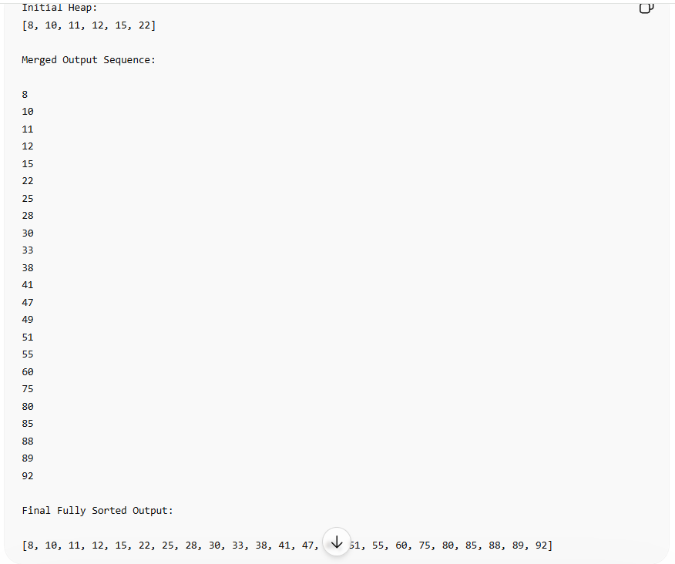

Conclusion
In this case study, External Merge Sort was used because the IPL log dataset size (50 GB) exceeded the available RAM capacity (8 GB), making traditional in-memory sorting impossible.
Chunk-based sorting allowed large data to be processed in smaller manageable portions, while k-way merge efficiently combined all sorted chunks using a min-heap. The PriorityQueue minimized comparison overhead and maintained efficient retrieval of the smallest timestamp element.
This approach significantly reduced disk I/O operations and improved scalability, making it highly suitable for real-world big-data systems such as streaming analytics, log processing, distributed databases, and large-scale reporting systems.
Github Link: https://github.com/ampssubrahmanyasreepad-svg/DSA-CaseStudies


